

Programming

**The DCU website**

Teacher:

Natalia stukalo

Student:

Ahmed Mohammed Alkali w66986

Rzeszów 20203

TABLE OF CONTENTS

* Website overview
* Website Sections
* CSS overview
* JavaScript overview
* Website screenshots
* Conclusion

**Description of topic, and objectives**

**Website Overview**

* The DCU website is a dedicated online platform for fans of the DC Universe. It serves as a hub of information, entertainment, and engagement for fans of DC comics, movies, TV shows, and games. The website features a user-friendly interface with easy navigation through various sections.
* The website has a clean layout and is easy to navigate with a menu that directs visitors to different sections of the site.
* The site features a homepage, an "About Me" section, a “Catalog" section, an “Portofolio" section, and a "Contact" section.

**The Home Page**

* The Home section welcomes visitors with captivating visuals and a brief introduction to the DC Universe. It showcases the iconic heroes and villains, highlighting the vast and dynamic world of DC Comics. Users are encouraged to explore the catalogue section to learn more about their favourite characters.
* The homepage also includes links to my social media profiles and a button that directs visitors to the "About Me" section of the site.

**About Me**

* The About section provides an overview of the DC Universe, emphasizing its rich history and diverse characters. It showcases the compelling stories and captivating narratives that have captivated fans for decades.
* The “Read More" button in this section takes us to another page that has different information about the dcu.

**Catalogue**

* The Catalogue includes Heroes, Villains, and Antiheroes sections delve deeper into the DC Universe's iconic characters. Each section presents a collection of heroes, villains, and antiheroes, accompanied by descriptions that showcase their unique qualities and contributions to the DC Universe.
* By click the ‘read more’ button you are taken to a different page that has some dcu heroes on them and some fact about tchem

**Portfolio**

* The Portfolio section showcases the latest projects in movies, series, and games related to the DC Universe. Users can explore and immerse themselves in the DC Universe's multimedia offerings, reliving classic moments and discovering new adventures.
* By clicking on the icon you are taken to a different page which has some of the latest series and movies in the dcu

**Contact**

* The Contact section provides a means for users to reach out and connect with the website administrators. A contact form allows users to send messages and inquiries, fostering interaction and engagement.
* This section includes a contact form where visitors can enter their name, email address, and message.
* Footer is also included

**CSS Overview**

* Universal settings: Resets margins, padding, box-sizing, and other properties.
* Root variables: Define custom variables for background colors, text colors, and main colors.
* HTML and body: Sets base font size, background color, and text color.
* Sections: Defines styling for sections, including minimum height and padding.
* Header: Styles the website header, including position, background, and navigation links.
* Home section: Centers and aligns content, including headings, text, and social media links.
* About section: Styles the background image and content, such as headings and paragraphs.
* Heroes section: Styles the section headings.
* Services section: Styles the container and individual service boxes, including icons and text.
* Portfolio section: Styles the section and individual portfolio items, including images and overlay layers.
* Contact section: Styles the section, including headings and form elements.
* Footer: Styles the footer section, including background, text, and social media icons.
* Media queries: Adjusts layout and styles for different screen sizes.

**The CSS Animation**

**Float image**

* The animation is called floatImage and has three keyframes (at 0%, 50%, and 100%) with different transform values applied to the element at each keyframe.
* The animation is applied to the .himg element using the animation property, which specifies the animation name (floatImage), the animation duration (4 seconds), the timing function (ease-in-out), and that the animation should repeat indefinitely (infinite).
* When the animation is applied, the .himg element will move up and down by 2.4rem (about 38 pixels) in a repeating animation loop.

**JS Overview**

1. Typed.js: This is a library that enables the creation of a typing effect on a webpage. In this code, it is used to create a typewriter effect that types out several strings one after the other.
2. ScrollReveal(): This is also a library that adds a scroll animation to a webpage. It is used to reveal certain elements of the webpage as the user scrolls down. The distance, duration, and delay properties are set for the animation to control the speed and timing of the reveal. The reveal() function is used to specify which elements should have the scroll animation, and the origin property is used to set the direction from which the elements should appear.

**Website Screenshots**

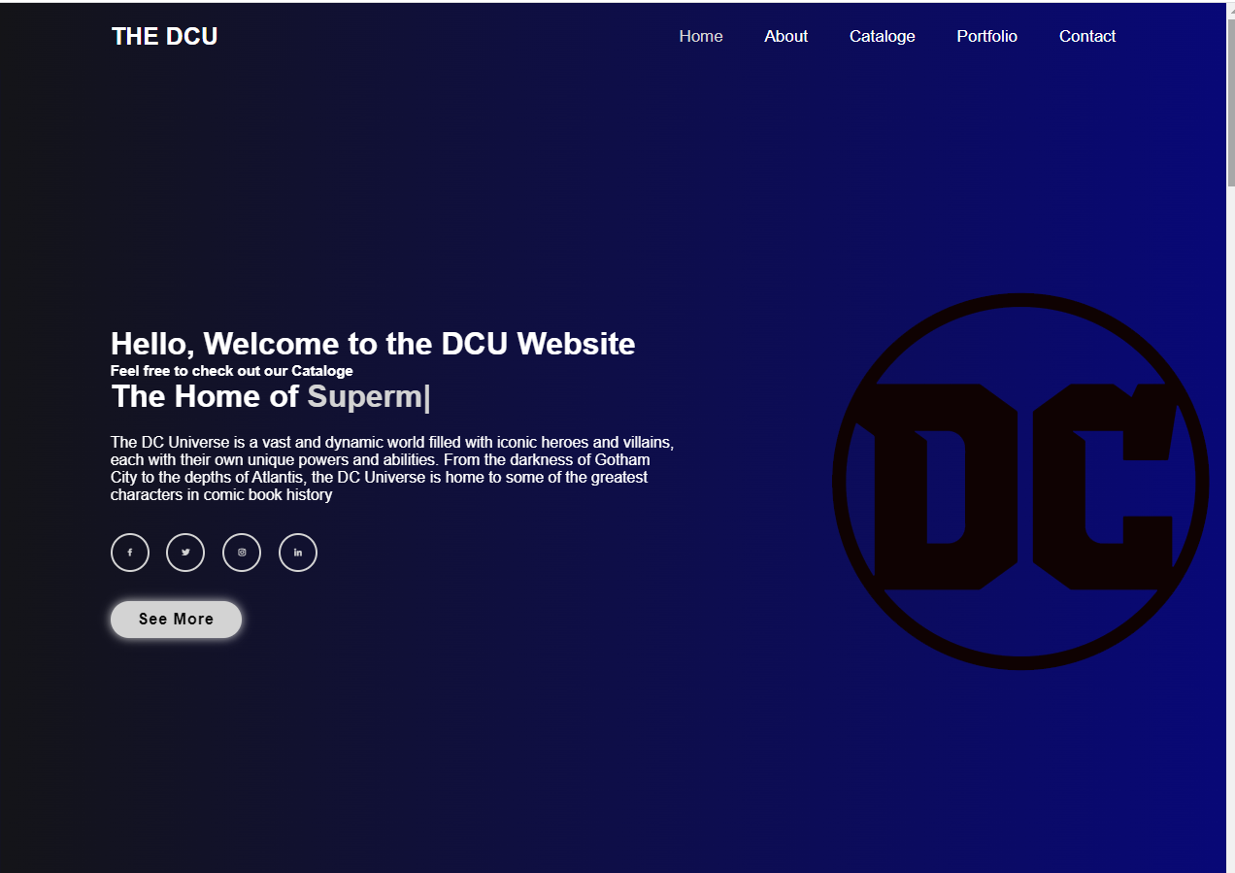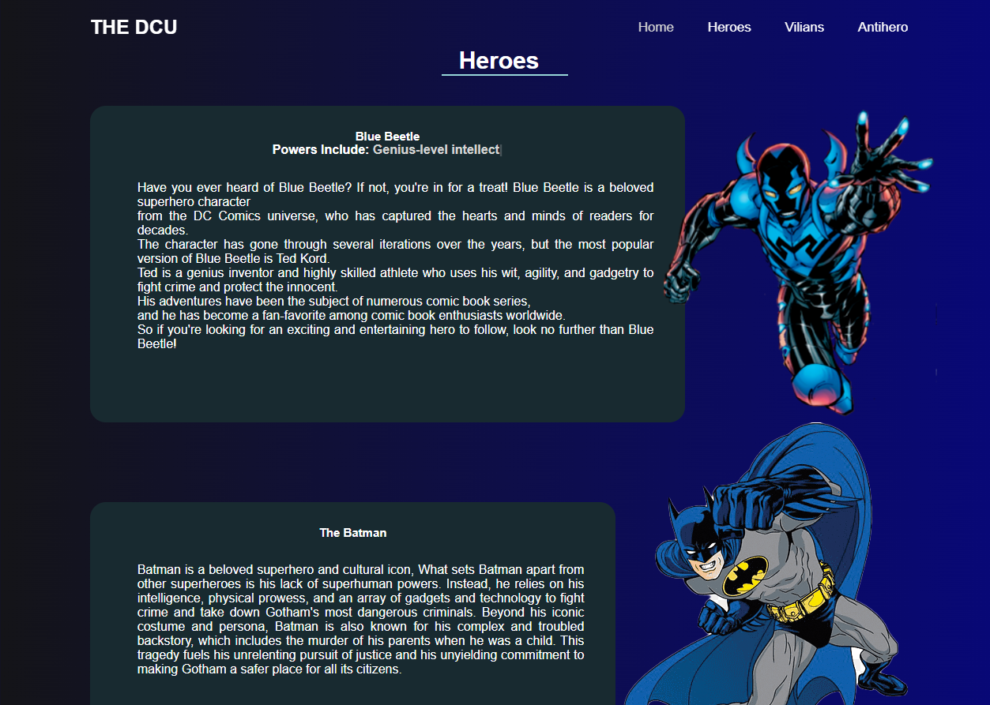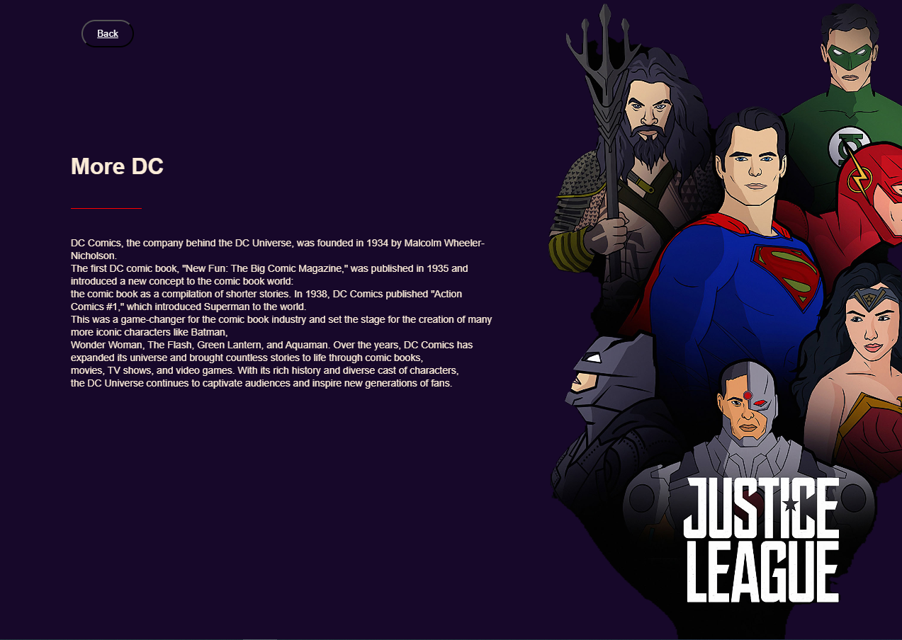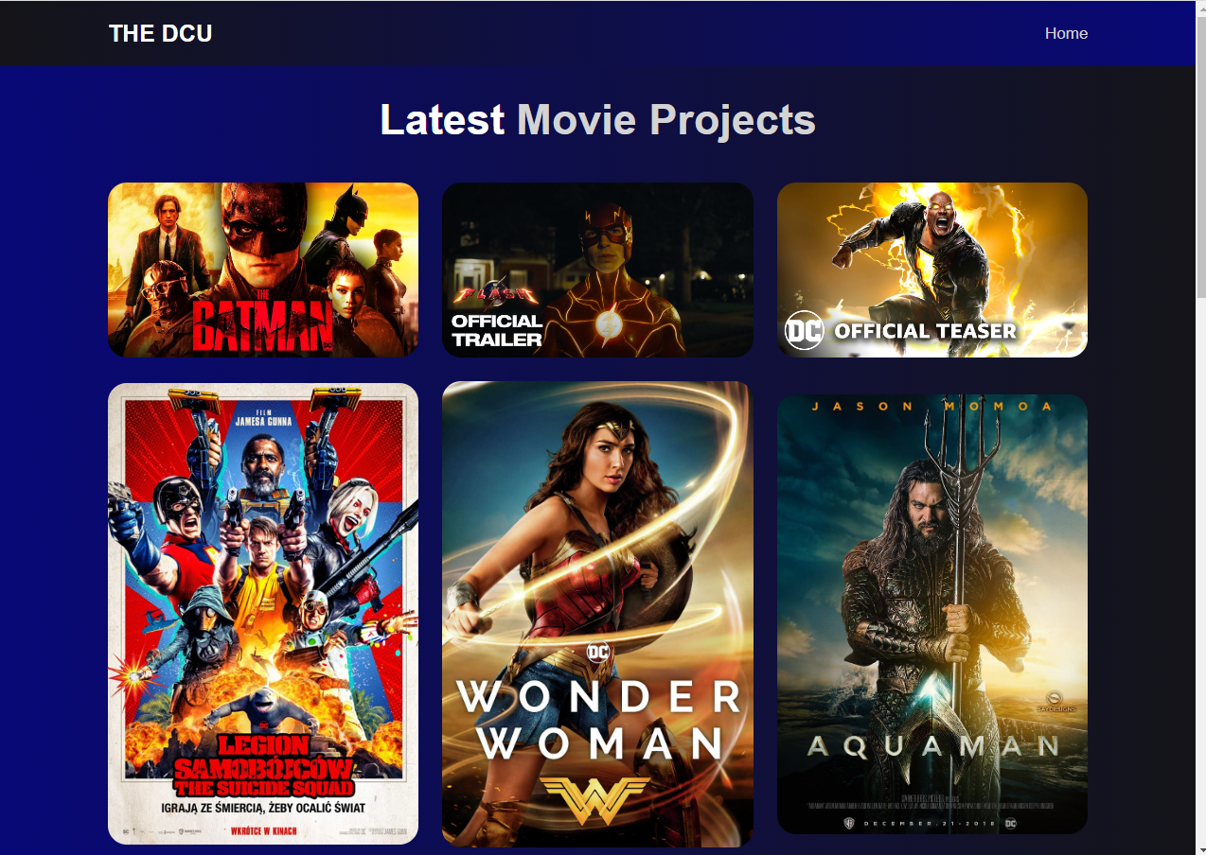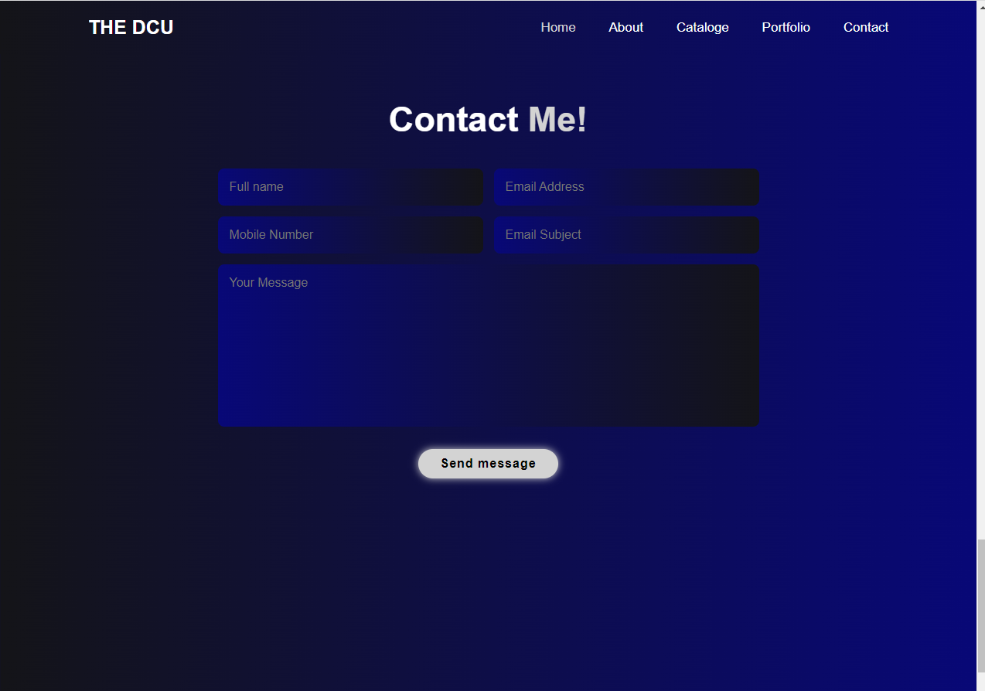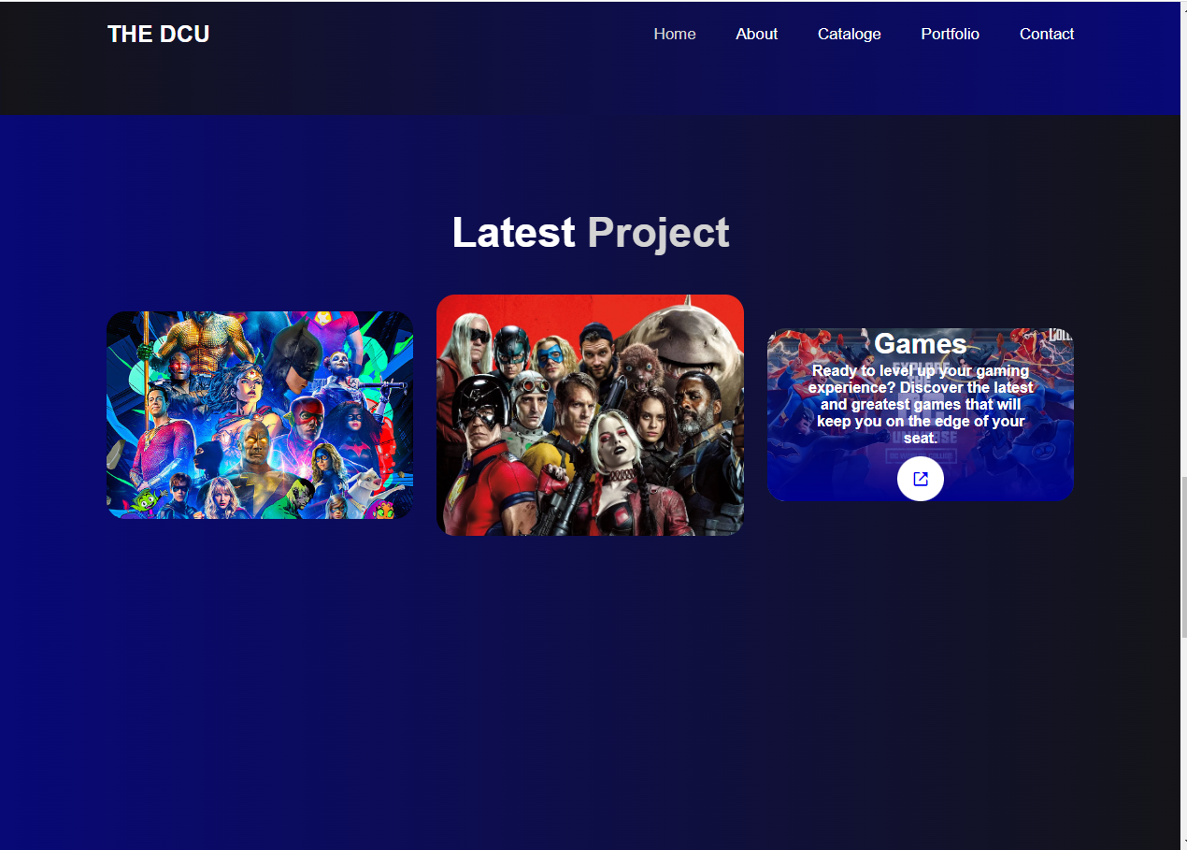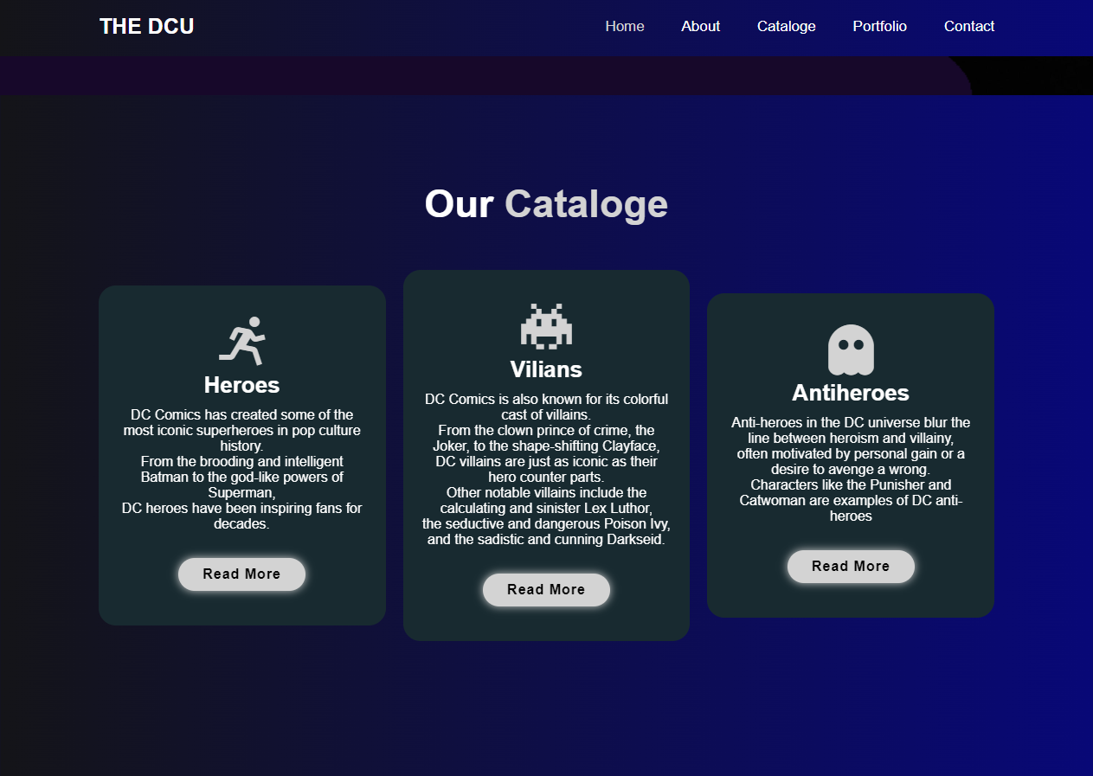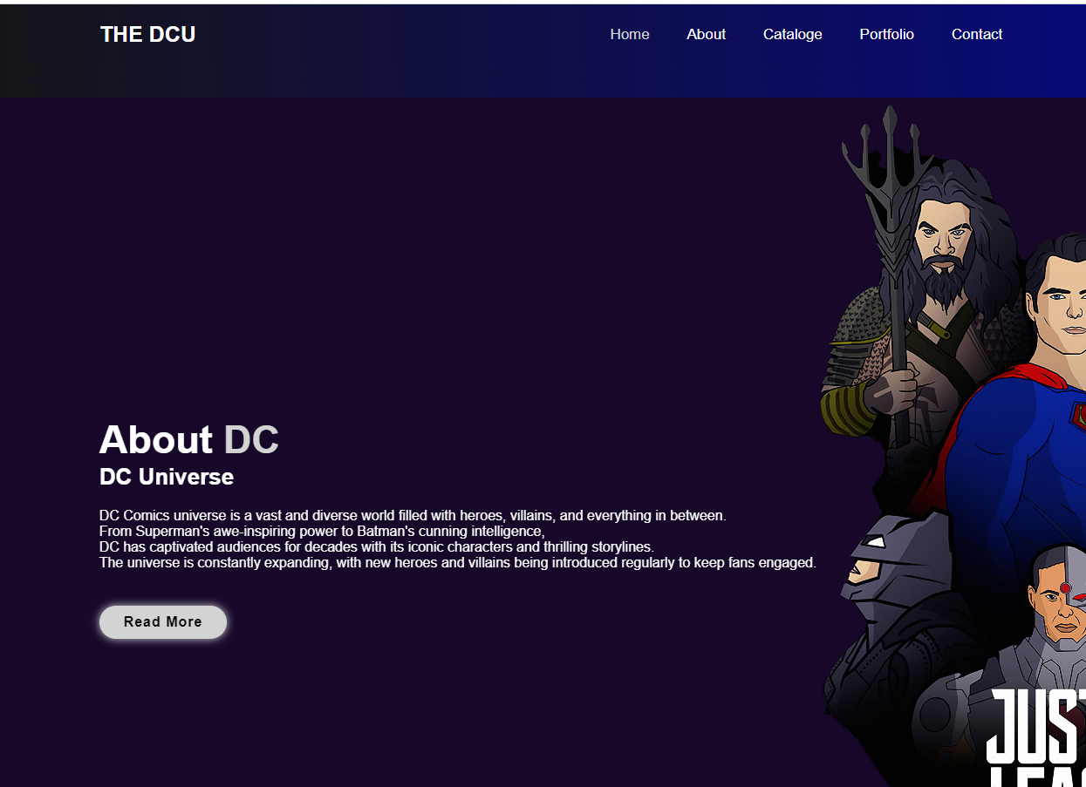

## DESCRIPTION OF THE TECHNOLOGIES USED

**LITERATURE**

1. Boxicons (Version 2.1.4): This library provides a collection of icons used throughout the website, enhancing the visual appeal and providing intuitive symbols for navigation and social media links.
2. React (Version 0.14.3) and ReactDOM (Version 0.14.3): React is a JavaScript library for building user interfaces, and ReactDOM is a package for rendering React components into the DOM. These libraries enable the creation of dynamic and interactive elements on the website.
3. Babel Core (Version 6.1.19): Babel is a JavaScript compiler that converts modern JavaScript code into backward-compatible versions. Babel Core is used to transpile JSX syntax, allowing the usage of React components in the website code.
4. Typed.js (Version 2.0.15): This library provides a typing effect, allowing text to be animated as if it's being typed in real-time. It is used to create the dynamic text effect in the website's home section.
5. ScrollReveal: ScrollReveal is a JavaScript library that adds scroll-based animations to elements on a web page. It enhances the user experience by animating elements as they come into view while scrolling.

**Conclusion**

* Overall, the DCU website aims to provide an immersive and informative experience for fans, allowing them to delve deeper into the DC Universe and stay connected with the latest updates and offerings.